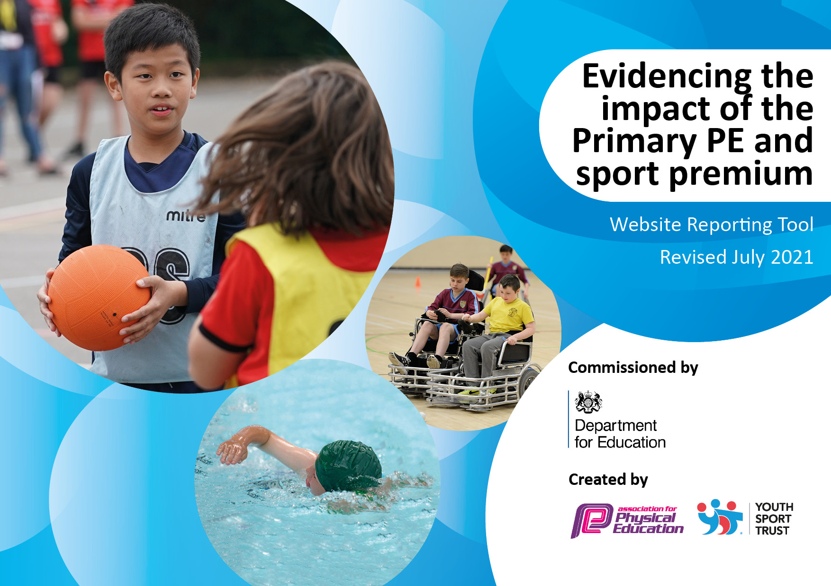
Completed July 2022
Brinkley Grove Primary School
Details with regard to funding

Total amount carried over from 2019/20 | £16,845
Total amount allocated for 2020/21 | £19,483
How much (if any) do you intend to carry over from this total fund into 2021/22? | £273
Total amount allocated for 2021/22 | £19,475
Total amount of funding for 2021/22. To be spent and reported on by 31st July 2022. | £19,748
Swimming Data

Meeting national curriculum requirements for swimming and water safety.
What percentage of your current Year 6 cohort swim competently, confidently and proficiently over a distance of at least 25 metres? | 76%
What percentage of your current Year 6 cohort use a range of strokes effectively [for example, front crawl, backstroke and breaststroke]? | 76%
What percentage of your current Year 6 cohort perform safe self-rescue in different water-based situations? | 70%
Schools can choose to use the Primary PE and sport premium to provide additional provision for swimming but this must be for activity over and above the national curriculum requirements. Have you used it in this way? | Yes/No

Action Plan and Budget Tracking

Academic Year: 2021/22 | Total fund allocated:£19,748 | Date Updated:31.3.21
Key indicator 1: The engagement of all pupils in regular physical activity – Chief Medical Officers guidelines recommend that primary school pupils undertake at least 30 minutes of physical activity a day in school |  |  |  | Percentage of total allocation:
 |  |  |  | 22%
Intent | Implementation |  | Impact | Sustainability
Pupils will have access to a range of quality PE equipment in order to engage in physical activity for at least 30 minutes daily. | Equipment and storage space will be purchased to engage children in sport. | £4,347 | Children have engaged in a wider range of sports and have achieved curriculum requirements. | Continue to monitor quality of equipment and usage.
Key indicator 2: The profile of PE being raised across the school as a tool for whole school improvement |  |  |  | Percentage of total allocation:
 |  |  |  | 8%
Intent | Implementation |  | Impact | Sustainability
High quality schemes of work will make teachers well equipped to teach quality lessons with the new range of equipment | Purchase schemes of work coverage the breadth of the curriculum. | £1,547 | Children are excited about PE and the skills they gain progress and an accelerated rate year by year. | Ensure schemes remain the best available. Look into possible alternatives.

Key indicator 3: Increased confidence, knowledge and skills of all staff in teaching PE and sport |  |  |  | Percentage of total allocation:
 |  |  |  | 17%
Intent | Implementation |  | Impact | Sustainability
Sports coaches and dance teachers will support teachers and staff to teach sports. | Employ high-quality trusted companies to teach PE lessons to increase knowledge and confidence of staff. | £3,429 | Pupils are fitter and have learned skills faster. | Bring in more coaches. Monitor the quality of the coaches.

