Smoothies & Growing Together
learning journey for year 5

AUTUMN FIRST HALF TERM…
Year Five’s topic for this half term is…

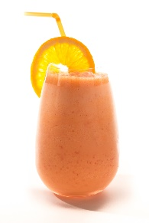
During this topic, we will be …

Smoothies:

Select and use ingredients according to their taste, texture and aesthetic qualities

To select and use tools and equipment e.g. Knives, Peelers and Blenders correctly

To make a fruit Smoothie

To apply the principles of nutrition and healthy eating and the benefits of eating fruit

Growing together:

To develop our understanding of the world around us and its impact on our health and wellbeing.

To show appreciation of the world around us and to develop empathy.

To develop our understanding of how our actions can impact the world around us.

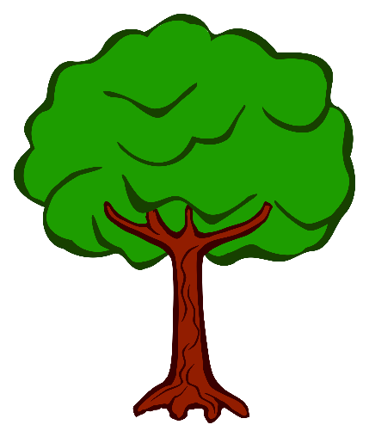
In English this half term, your child will be …
- Learning how to write a suspense story opening.
- Using effective vocabulary and language techniques

In maths, your child will be…
- Reading, writing and comparing numbers up to 1,000,000.
- Counting forward and backward in powers of 10 up to 1,000,000
- Interpreting negative numbers in context
- Solving number problems

In Outdoor PE, your child will be learning…
- To work in pairs or small groups to develop attacking and defending skills.
- To work co-operatively as a team.
- To observe and select information to evaluate their own and others’ work.

In Indoor PE, your child will be learning…
Swimming:
- Perform safe self-rescue in different water based situations
- Swim competently, confidently and proficiently over a distance of at least 25 metres
- Use a range of strokes effectively, for example, front crawl, backstroke and breaststroke.

