AUTUMN FIRST

HALF TERM…

Year Three’s topic for this half term is…
Moving Monsters

In this topic, your child will be learning …
To design, make and evaluate a variety of products using different materials.
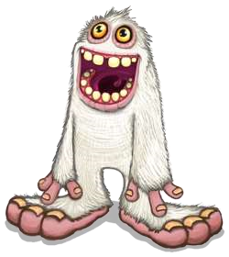
To understand and use mechanical systems in their products like a simple lever and pneumatics.

In English this half term, your child will be learning…
To write a story about conflict and resolution. This will be based on the book, ‘The Day the Crayons Quit’ by Drew Daywalt.

In Maths this half term, your child will be learning…
To recognise what each digit means in a number to 1000.
To order and compare three-digit numbers.
To add and subtract two and three-digit numbers using a variety of methods.

In PE this half term, we will be developing ball skills focusing on passing and receiving a ball with hands or feet. In Gymnastics, we will be exploring different type of movement such as stretching, curling and balancing and putting these into sequences.

In Science this half term, we will be investigating and sorting materials based on their properties.

During this half term, we will be focusing on the school’s three golden rules:
- Be kind
- Be polite
- Show respect

