BRINKLEY GROVE SCHOOL MENU – November 2020 WEEK 1
MONDAY | TUESDAY | WEDNESDAY | THURSDAY | FRIDAY
Cheese & Tomato Pizza  Sweetcorn  Mixed Salad  Toffee Crispie | Pasta Bolognaise  Or  Vegetarian Pasta Bolognaise  Vegetable Medley  Crusty Wholemeal Bread  Fresh Fruit Platter | Children’s Favourite Burger  OR  Vegetarian Burger  Diced Potatoes  Baked Beans  Cucumber & Sweetcorn Salad  Seasonal Fruit Crumble & Custard  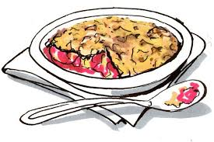 | Chicken Pie and Gravy  OR  Vegetarian Sausage Roll  Gravy  Mashed Potato  Carrots  Cabbage  Fruit Jelly & Cream | Omega 3 Young’s Fish Fingers  OR  Quorn Dippers  Chips  Peas  Sweetcorn  Chocolate Brownie
Fresh Bread and Cold Milk available everyday

BRINKLEY GROVE SCHOOL MENU – November 2020 WEEK 2
MONDAY | TUESDAY | WEDNESDAY | THURSDAY | FRIDAY
Cheese & Tomato Pizza  Sweetcorn  Salad  Fruit, Yoghurt,  Granola | Sausage and Gravy  OR  Vegetarian Sausage  Mashed Potatoes  Green Beans  Carrots  Shortbread Biscuit | Homemade Beef Lasagne  OR  Homemade Vegetarian Lasagne  Wholemeal Crusty Bread  Vegetable Medley  Chocolate Sponge & Chocolate Custard | Omega 3 Fish Fingers  OR  Veggie Nuggets  Chips  Peas  Baked Beans  Fresh Fruit Platter | Roast Turkey  Gravy  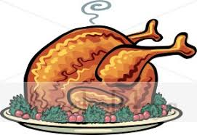  OR  Roast Quorn Fillet & Gravy  Roast Potatoes  Yorkshire Pudding  Carrots  Cabbage  Schools Favourite Flapjack
Fresh Bread and Cold Milk available every day

